**INDEX**

|  |  |  |  |  |
| --- | --- | --- | --- | --- |
| **SNO.** | **DATE** | **TITLE** | **PAGE NO.** | **REMARKS** |
| 1. | 07-02-2025 | To study various hardware tools that are used in networking. | 2-8 |  |
| 2. | 07-02-2025 | To study various topologies that are used in networking. | 9-16 |  |
| 3. | 07-02-2025 | To chart out various characteristics of IPv4 and IPv6. | 17-18 |  |
| 4. | 14-02-2025 | To study the various Cabling Standards using networks. | 19-20 |  |
| 5. |  |  |  |  |
| 6. |  |  |  |  |
| 7. |  |  |  |  |
| 8. |  |  |  |  |
| 9. |  |  |  |  |
| 10. |  |  |  |  |
| 11. |  |  |  |  |
| 12. |  |  |  |  |
| 13. |  |  |  |  |
| 14. |  |  |  |  |

**Experiment 1**

**Aim**

To study various hardware tools that are used in networking.

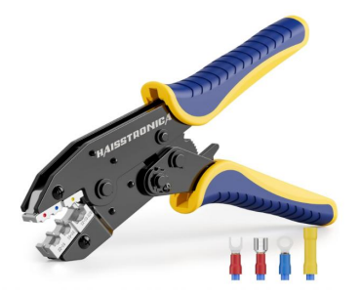**1. Cable Crimper**

* **Purpose:**  
  To attach connectors (like RJ45 for Ethernet) to the ends of network cables.
* **How It Works:**  
  It crimps (presses) the pins of the connector into the cable's individual wires, creating a strong electrical and mechanical connection.
* **Uses:**
  + Setting up Ethernet cables for local area networks (LANs).
  + Repairing or customizing network cables for specific lengths.

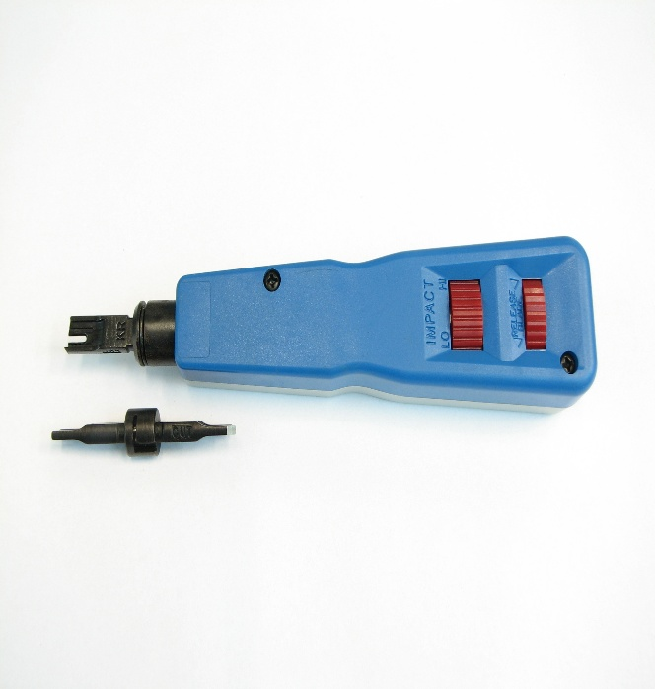**2. Punch-Down Tool**

* **Purpose:**  
  To insert and secure wires into patch panels, keystone jacks, or punch-down blocks.
* **How It Works:**  
  The tool pushes the wire into the slot while simultaneously cutting off excess wire, ensuring a secure connection.
* **Uses:**
  + Structured cabling installations in data centres and offices.
  + Organizing and terminating network cables for cleaner connections.

**3. Cable Stripper**

* **Purpose:**  
  To remove the outer insulation from network cables (like CAT5, CAT6).
* **How It Works:**  
  The tool cuts through the cable's jacket without damaging the inner wires.
* **Uses:**
  + Preparing cables for crimping or punch-down.
  + Efficiently stripping large volumes of network cables during installation.

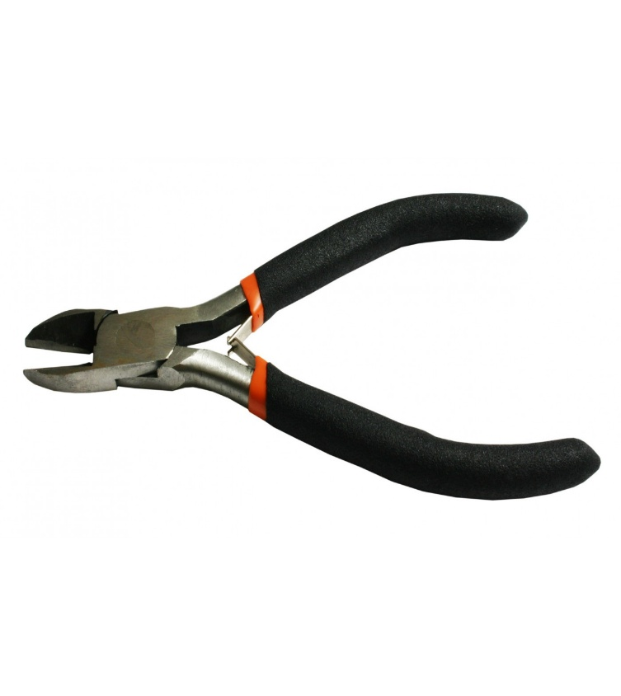**4. Wire Cutter**

* **Purpose:**  
  To cut through various types of network cables cleanly.
* **How It Works:**  
  Sharp blades slice through cables, ensuring a clean edge for easier handling and connections.
* **Uses:**
  + Trimming excess cable during installations.
  + Cutting Ethernet, coaxial, and telephone wires.

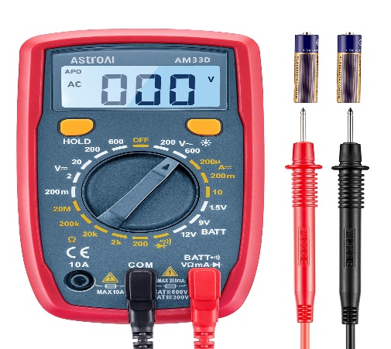**5. Multimeter**

* **Purpose:**  
  To measure electrical properties such as voltage, current, resistance, and continuity in network cables.
* **How It Works:**  
  Connect the probes to the circuit or cable, and the multimeter displays the measurement values.
* **Uses:**
  + Troubleshooting network connections.
  + Checking for breaks, shorts, or incorrect wiring in cables.

**6. Tone Generator**

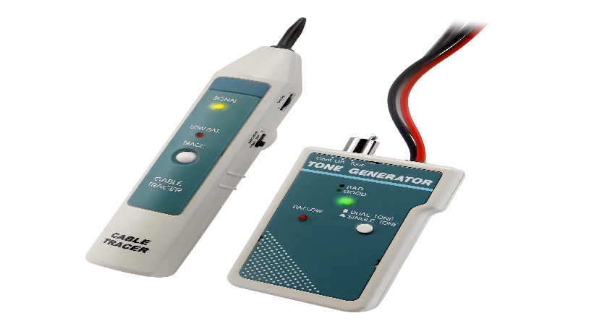

* **Purpose:**  
  To identify specific cables in a bundle or locate faults in network wiring.
* **How It Works:**  
  The generator sends a distinct tone through the cable, which is detected using a tone probe at the other end.
* **Uses:**
  + Identifying cables in crowded patch panels.
  + Diagnosing breaks or faults in wiring.

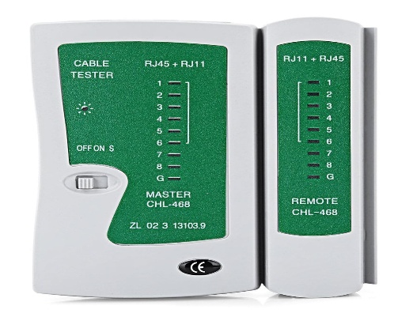**7. Cable Tester**

* **Purpose:**  
  To test the integrity, continuity, and configuration of network cables.
* **How It Works:**  
  The tester checks the wiring of the cable and displays any faults, such as open connections or miswiring.
* **Uses:**
  + Verifying newly crimped cables.
  + Ensuring proper connections in LAN setups.

**8. Loopback Adapter**

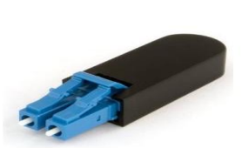

* **Purpose:**  
  To test and diagnose network ports and connections.
* **How It Works:**  
  The adapter loops signal back to the network port to check if data transmission and reception are functioning correctly.
* **Uses:**
  + Diagnosing faulty network cards.
  + Testing switches and routers in network setups.

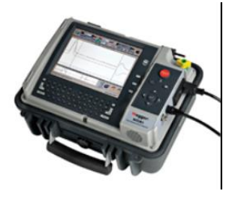**9. Time Domain Reflectometer (TDR)**

* **Purpose:**  
  To locate faults in copper and fibre optic cables by measuring reflections along the cable length.
* **How It Works:**  
  Sends an electrical pulse through the cable and measures the time it takes for reflections to return.
* **Uses:**
  + Identifying breaks, shorts, or impedance mismatches in network cables.
  + Precise fault location for cable repairs.

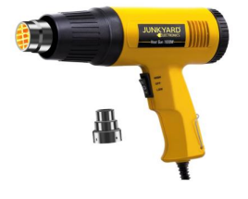**10. Heat Gun for Shrink Tubing**

* **Purpose:**  
  To shrink heat-shrink tubing around cable connections for insulation and protection.
* **How It Works:**  
  The gun blows hot air that causes the tubing to contract tightly around the cables.
* **Uses:**
  + Securing cable splices and connections.
  + Providing insulation in electrical and network wiring.

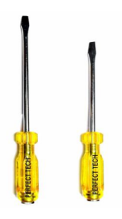**11. Screwdriver Set**

* **Purpose:**  
  To assemble and disassemble network hardware like switches, routers, and patch panels.
* **How It Works:**  
  Different screwdriver heads (Phillips, flathead) fit into screws to tighten or loosen them.
* **Uses:**
  + Mounting network equipment in racks.
  + Repairing or upgrading network components.

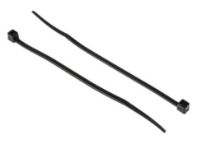**12. Cable Tie**

* **Purpose:**  
  To organize and secure bundles of network cables.
* **How It Works:**  
  The tie is wrapped around the cables and tightened to hold them together.
* **Uses:**
  + Reducing cable clutter in data centres.
  + Securing cables to racks or walls.

**13. Scissors**

* **Purpose:**  
  To cut network cables, insulation, and other materials during installation.
* **How It Works:**  
  Sharp blades provide clean and precise cuts for easier cable handling.
* **Uses:**
  + Trimming cables during setup.
  + Cutting tape and insulation for cable management.

**Experiment 2**

**Aim**

To study various topologies that are used in networking.

**Network Topology**

Network topology is the way devices are connected in a network. It defines how these components are connected and how data transfer between the network. Understanding the different types of network topologies can help in choosing the right design for a specific network.

**Types of Network Topologies**

Common types of network topologies in wired Networks include bus, star, ring, mesh, and hybrid topologies.

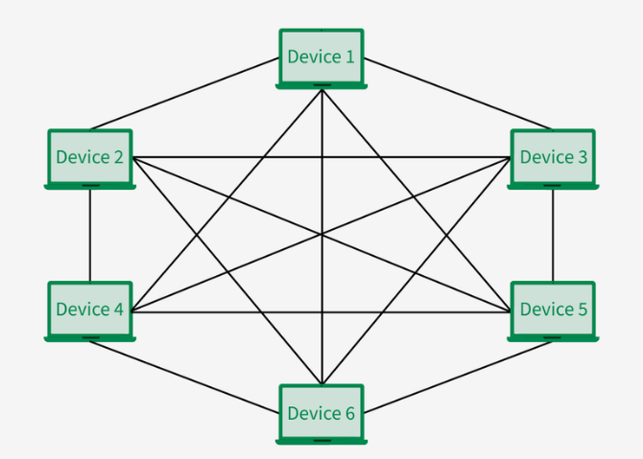**I. Mesh Topology**

**1. Characteristics of Mesh Topology**

* **Network Configuration:** Every device is interconnected with every other device, providing multiple routes for data transmission.
* **Node Connectivity:** Nodes are completely connected via dedicated links, allowing information to travel from node to node.
* **Number of Links:** For N nodes, the number of required links is N(N-1)/2.
* **Data Transmission:** Each computer not only sends its own signals but also transfers data from other computers.
* **Connection Type:** Connections within the mesh can be wired or wireless.
* **IEEE Standards:** Mesh networks often comply with IEEE 802.11s standards for wireless mesh communication, providing efficient routing and connectivity.

**2. Advantages of Mesh Topology**

* In case of failure of a single device, the entire network didn’t break.
* There is no traffic problem as there is a dedicated point to point links for every device.
* Mesh Topology provides high privacy and security.
* Data transmission is more consistent because failure doesn’t disrupt its processes.
* Adding new devices won’t disrupt transmission of data.

**3. Disadvantages of Mesh Topology**

* Mesh Topology is costly as compared to the other network topologies i.e. star, bus, point to point topology.
* Installation of nodes are difficult in mesh topology.
* Power requirement is higher as all the nodes will need to remain active all the time and share the load.
* Each node requires an extra utility cost.
* More maintenance is required in mesh topology.

**4. Applications of Mesh Topology**

* **Wireless Networks:** Many homes and small office spaces uses Mesh Wi-Fi System for better internet coverage and connectivity.
* **Industrial and Manufacturing Networks:** Many industries uses mesh topology to control machinery, ensuring better productivity.
* **Smart Homes:** Some advanced homes also use mesh topology for connecting home appliances like smart lights, security systems, etc.
* **Military Communication:** Mesh Topology are used in Military Purposes as if one connection fails, then there is always a chance of another connection.

**II. Star Topology**

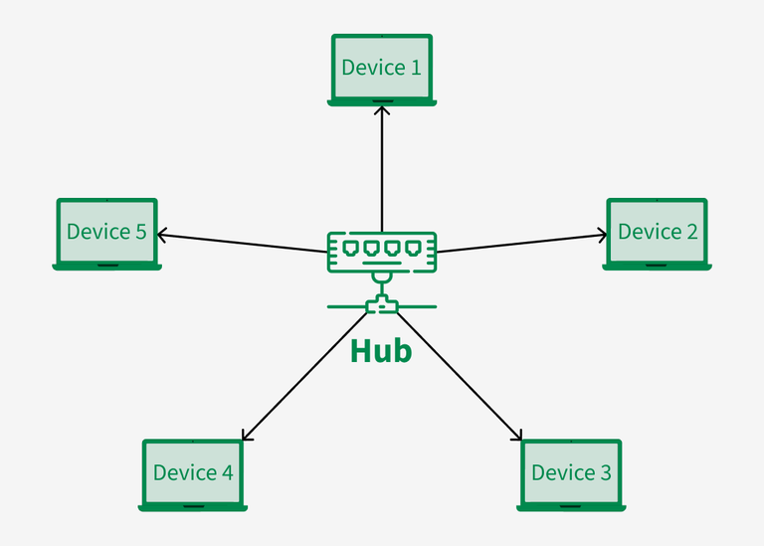

**1. Characteristics of Star Topology**

* + **Central Hub:** Each device is connected to a central node called a hub or switch, which manages data flow.
  + **Data Transmission:** Devices communicate by sending data to the hub, which then forwards it to the target device.
  + **Topology Type:** Commonly used in Local Area Networks (LAN).
  + **Number of Links:** Requires **N** links to connect **N** devices to the hub.
  + **Network Management:** The hub or switch controls and manages all network functions.
  + **IEEE Standards:** Star topology networks often follow IEEE 802.3 (Ethernet) and IEEE 802.11 (Wi-Fi) standards for wired and wireless communication, respectively.

**2. Advantages of Star Topology**

* It is very reliable as if one cable or device fails then all the others will still work.
* It is high performing as no data collisions can occur.
* It is less expensive because each device only needs one I/O port and wishes to be connected to the hub with one link.
* Easy fault detection because the links are often easily identified.
* If N devices are connected to each other in star, then the number of cables required to attach them is N. So, it’s easy to line up.

**3. Disadvantages of Star Topology**

* If the connecting network device (network switch) fails, the nodes attached are disabled and can’t participate in network communication.
* More expensive than linear bus topology due to the value of the connecting devices (network switches).
* If the hub goes down everything goes down, none of the devices can work without the hub.
* Extra hardware is required (hubs or switches) which adds to the cost.
* Performance is predicated on the one concentrator i.e. hub.

**4. Applications of Star Topology**

* **Home Networks:** Star Topology is used in a home network where all devices connect to a connected to a central router that manages the Internet.
* **ATM Networks:** In banks, ATMs are also connected in as a star network, as it helps in managing data efficiently.
* **Hospital Networks:**Hospital devices, medicinal equipment are connected in the star topology. It helps in easily accessing data records.
* **CCTV Networks:** Star Topology are also used in CCTV Networks where multiple cameras are connected to central video recorder.

**III. Bus Topology**

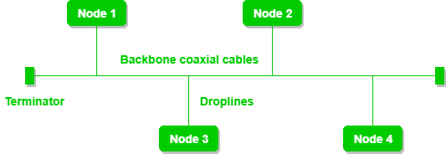

**1. Characteristics of Bus Topology**

* + **Data Transmission:** Data is transmitted through a single main cable that reaches every node in the network.
* **Address Checking:** Each node checks the destination address (MAC/IP) in the transmitted data.
* **Address Match:** If the address matches, the node processes the data.
* **Address Mismatch:** If the address does not match, the node ignores the data.
* **Communication:** All communication between nodes occurs through the main network cable.
* **IEEE Standards:** Bus topology networks commonly follow IEEE 802.3 standards for Ethernet communication.

**2. Advantages of Bus Topology**

* It is the easiest network topology for linearly connecting peripherals or computers.
* It works very efficiently well when there is a small network.
* The length of cable required is less than a star topology.
* It is easy to connect or remove devices in this network without affecting any other device.
* Very cost-effective as compared to another network topology i.e. mesh and star

**3. Disadvantages of Bus Topology**

* Bus topology is not good for large networks.
* Identification of problems becomes difficult if the whole network goes down.
* Troubleshooting individual device issues is very hard.
* Need terminators are required at both ends of the main cable.
* Additional devices slow the network down.
* If the main cable is damaged, the whole network fails or splits into two.

**4. Applications of Bus Topology**

* **Local Area Networks (LANs):** Bus topology was traditionally utilized in Ethernet LANs, mainly in older implementations wherein coaxial cables have been daisy-chained to connect computer systems.
* **Industrial Control Systems:** In industrial control system, bus topology is frequently used for connecting sensors, actuators, and different devices in distributed manipulate systems.
* **Instrumentation Networks:** Bus topology is appropriate for connecting devices, meters, and records acquisition gadgets in laboratory or commercial environments.
* **Building Automation Systems:** Bus topology is employed in building automation and HVAC (heating, ventilation, and air conditioning) structures to attach sensors, thermostats, actuators, and other manage devices.

**IV. Ring Topology**

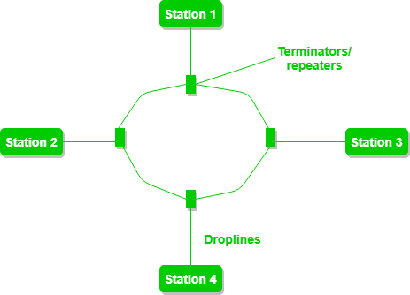

**1. Characteristics of Ring Topology**

* + **Network Configuration:** Devices are connected in a circular data path, forming a ring structure.
  + **Node Connectivity:** Each device is connected to exactly two neighbouring devices.
  + **Repeaters Usage:** Repeaters are used in networks with a large number of nodes to prevent data loss and ensure smooth data transmission.
  + **Data Transmission:** Packets travel from one device to another in a circular manner until they reach the desired destination.
  + **Network Terminology:** Devices connected in this setup are collectively referred to as a **ring network**.
  + **IEEE Standards:** Ring topology networks often comply with IEEE 802.5 standards for token ring communication.

**2. Advantages of Ring topology**

* In this data flows in one direction which reduces the chance of packet collisions.
* In this topology additional workstations can be added after without impacting performance of the network.
* Equal access to the resources.
* There is no need of server to control the connectivity among the nodes in the topology.
* It is cheap to install and expand.
* Minimum collision.
* Speed to transfer the data is very high in this type of topology.
* Ring network is extremely orderly organized where every device has access to the token and therefore the opportunity to transmit.

**3. Disadvantages of Ring topology**

* Due to the Uni-directional Ring, a data packet (token) must have to pass through all the nodes.
* If one workstation shuts down, it affects whole network or if a node goes down entire network goes down.
* It is slower in performance as compared to the bus topology
* It is Expensive.
* Addition and removal of any node during a network is difficult and may cause issue in network activity.
* Difficult to troubleshoot the ring.
* In order for all the computer to communicate with each other, all computer must be turned on.

**4. Applications of Ring Topology**

* + **Telecommunication Networks:** Used in telephone networks and broadband communication systems to maintain consistent data flow.
  + **Campus and Metropolitan Area Networks (MANs):** Ideal for connecting buildings in campuses and for MANs due to its structured data routing.
  + **Industrial Control Systems:** Common in factories and industrial setups where continuous data transmission is crucial for machine coordination.
  + **Token Ring Networks:** Implemented in legacy systems following the IEEE 802.5 standard to manage traffic and avoid collisions.

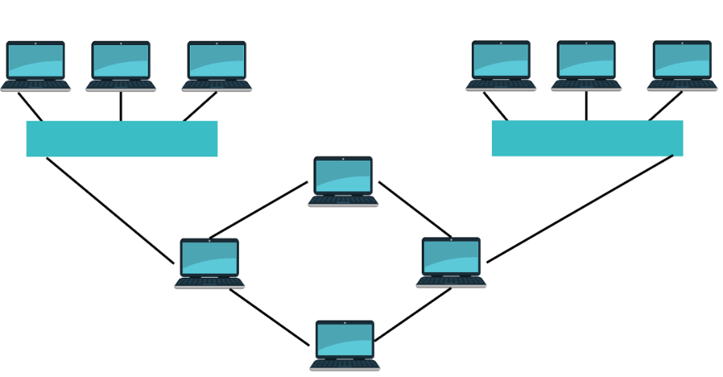**V. Hybrid Topology**

**1. Characteristics of Hybrid Topology**

* + **Definition:** A network topology that combines two or more different types of network topologies (e.g., bus, ring, and mesh).
  + **Flexible Design:** The choice of topologies depends on factors like the number of computers, their location, and required network performance.
  + **Custom Configuration:** Network sections consist of configurations tailored to specific needs.
  + **Scalability:** Easily scalable by incorporating additional topologies as required.
  + Performance Optimization: Combines the strengths of different topologies to optimize network performance.
  + **IEEE Standards:** Hybrid topologies may follow various IEEE standards such as IEEE 802.3 (Ethernet) and IEEE 802.11 (Wi-Fi) depending on the topologies used.

**2. Advantages of Hybrid Topology**

* Adding a new node or deleting the existing node is easy in hybrid topologies.
* Hybrid topology is more secure, reliable, and scalable as compared to individual star, ring and mesh topology.
* Error detection and troubleshooting is easier in hybrid topology.
* When an organization has a large geographical area utilizing hybrid topology is considered as better option.
* Traffic with large volume is handled easily by the hybrid topology.
* The overall performance and speed are greater in hybrid topology.

**3. Disadvantages of Hybrid Topology**

* The design and implementation of hybrid network topology is difficult.
* More number of cables and other physical devices are required for hybrid topology.
* The process of installation of hybrid topology is difficult.
* The overall implementation, setup and process of hybrid topology is much costlier.

**4. Applications of Hybrid Topology**

* + **Enterprise Networks:** Suitable for large organizations to efficiently manage diverse departments with varying network requirements.
  + **Data Centres:** Used to handle complex networking demands and provide fault tolerance.
  + **Telecommunication Systems:** Ideal for building reliable and scalable communication infrastructure.
  + **Campus Networks:** Combines different topologies for connecting multiple buildings and departments.

|  |  |  |  |  |  |
| --- | --- | --- | --- | --- | --- |
| **Features** | **Mesh Topology** | **Star Topology** | **Bus Topology** | **Ring Topology** | **Hybrid Topology** |
| **Structure** | Every device is connected to every other device | All devices are connected to a central hub | Single main cable connects all devices | Devices form a circular data path | Combination of two or more topologies |
| **Data Transmission** | Multiple routes for data | Data passes through the central hub | Data travels along the main cable | Data travels in one direction or both | Depends on combined topologies |
| **Reliability** | Highly reliable (multiple paths) | Moderately reliable (depends on hub) | Less reliable (main cable failure affects the network) | Moderately reliable (repeater required for large networks) | Highly reliable (flexibility to choose fault-tolerant paths) |
| **Scalability** | Difficult to scale | Easy to scale by adding devices | Limited scalability | Difficult to scale | Highly scalable |

**Experiment 3**

**Aim**

To chart out various characteristics of IPv4 and IPv6.

**What is an IP Address?**

An IP (Internet Protocol) address is a unique identifier assigned to each device connected to a network. It enables communication between devices by specifying source and destination addresses. The two major versions in use today are **IPv4 (Internet Protocol Version 4)** and **IPv6 (Internet Protocol Version 6)**.

**Comparison Table: IPv4 vs. IPv6**

|  |  |  |
| --- | --- | --- |
| **Feature** | **IPv4** | **IPv6** |
| **Address Length** | |  | | --- | | 32-bit (4 octets) |  |  | | --- | |  | | 128-bit (8 groups of hexadecimals) |
| **Address Format** | Decimal (e.g., 192.168.1.1) | Hexadecimal (e.g., 2001:0db8:85a3::8a2e:0370:7334) |
| **Total Addresses** | ~4.3 billion | ~340 undecillion (2^128) |
| **Header Size** | 20 bytes | 40 bytes (simplified for efficiency) |
| **Address Configuration** | Manual or DHCP | Auto-configuration (SLAAC) and DHCPv6 |
| **Security** | IPsec optional | IPsec mandatory |
| **Broadcast Support** | Yes | No (replaced with multicast & anycast) |
| **Fragmentation** | Done by sender & routers | Done only by sender |
| **Quality of Service (QoS)** | Limited | Built-in support |
| **Adoption** | Widely Used | Gradually increasing |

**Key Findings**

* IPv6 addresses are longer and more complex than IPv4.
* IPv6 supports auto-configuration, eliminating the need for DHCP in many cases.
* IPv6 eliminates NAT (Network Address Translation), allowing direct communication between devices.
* Packet headers in IPv6 are optimized for faster processing.
* IPv6 has built-in support for security features like IPsec.

**Advantages and Challenges of IPv6**

|  |  |  |
| --- | --- | --- |
| **Feature** | **Advantages** | **Challenges** |
| **Address Space** | 128-bit, practically unlimited | Complex to remember |
| **Security** | Built-in IPsec for encryption | Not fully enforced globally |
| **Efficiency** | Simpler packet headers, faster routing | Requires network upgrades |
| **Auto-configuration** | No need for DHCP in many cases | Some legacy systems don’t support it |

|  |  |  |
| --- | --- | --- |
|  |  |  |
|  |  |  |
|  |  |  |
|  |  |  |

**Experiment 4**

**Aim**

To study the various Cabling Standards using networks.

**What are Cabling Standards?**

Cabling standards in networking define the specifications for cables, connectors, and installation methods to ensure reliable communication and interoperability between devices. These standards are developed by organizations such as the TIA (Telecommunications Industry Association), IEEE (Institute of Electrical and Electronics Engineers), and ISO (International Organization for Standardization).

**Types of cabling standards**

There are several types of cabling standards, used in networking. They all have several important properties making them useful in many different scenarios. These cabling standards in ethernet are termed as ‘cat’ and are grouped into sequentially numbered categories, based upon their individual specifications. These categories clarify the usage and the capabilities of the required cable, making it easier for non-technical users.

|  |  |  |
| --- | --- | --- |
| **Standard** | **Speed** | **Limitation** |
| CAT3 | 16Mbps | Ineffective for Higher - speed networks often found in older 10 BaseT networks, now obsolete. |
| CAT5 | 100Mbps | Range of 100 meters |
| CAT5e | 1000Mbps | Range of 100 meters |
| CAT6 | 10/100/1000 Mbps and 10 Gbps | Range of 100 meters |
| CAT6e | 10/100/1000 Mbps and 10 Gbps | Range of 100 meters |
| CAT7 | 10/100/1000 Mbps and 10 Gbps | Range over 100 meters. |

**Ethernet deployment standards:**

The distance specification for various media type is as given below:

|  |  |  |
| --- | --- | --- |
| **Standard** | **Media** | **Max. Length** |
| **1000BaseT** | Cat 5 UTP, 4 pair | 100 meters |
| **1000BaseSX** | Multi-mode Fiber cable | 260 meters |
| **1000BaseLX** | Single mode Fiber cable | 3 km |
| **100Base-FX** | Multi-mode Fiber cable | 2km |
| **10GBase-SR** | Multi-mode Fiber cable | 26-82m |
| **10GBaseER** | Single mode Fiber cable | 40km |
| **10GBaseSW** | Multi-mode Fiber cable | 200M |
| **10GBaseT** | Cat 6a (or higher) | 100m |